The Design and Development Specification for Cloud Technology Solution

康姆德润达（无锡）测量技术有限公司
Comde-Derenda (Wuxi) Measuring Technologies Co., Ltd

Issue Date：April 8, 2016 Implementation date：April -, 2016

Preface

This standard is initiated and managed by the Department of CDW RnD Engineering.

Signature Page

 | Title/Role | Signature | Date
Prepared by | CDW RnD Manager | Alpha Chen | 04/08/2016
Approved by | -
Approved by | CDW CEO
Approved by | -

Revision History

Revision Letter | Originator | Date | Change Description
0.1 | Alpha Chen | 04/08/2016 | Initial Release

Table of Content
1. Table of Content 4
1. Scope 6
2. Acronyms and Abbreviations 6
3. Overview 7
4. Purpose 8
4.1. The Traditional Solution 8
4.2. The Cloud Solution 9
5. Functional Description 9
5.1. The CDW cloud architecture 10
5.2. Samplers 12
5.2.1. PNT-18TDM 12
5.3. RFID Rings 14
5.3.1. Data Information recorded in RFID Ring 14
5.4. Weighing Unit 17
5.5. The Cloud Server 19
5.6. The Cloud Database 20
5.7. Online APM modules 20
5.7.1. APM-2 21
5.7.2. APM-6 22
5.8. Mobile UAP 23
5.9. PC UAP 23
5.10. The extended interface 24
6. DnD Engineering Process 25
7. Specialty Engineering Services 26
7.1. Reliability/Maintainability/Availability Engineering 26
7.2. Human Factors Engineering 26
7.3. Environmental & Electromagnetic Engineering (EEE) 26
8. Appendix 26

Scope
The design and development specification (DnDS) for Cloud Technology Solution (CTS) describes objectives, technologies, and the development life cycle(s) to be used to design and develop the network platform for the interconnection, information sharing, cloud storage, mass-data analysis and the remote control of Comde-Derenda products based on the cloud technology.
DnDS is a phased process that spans through requirements generation to final customer delivery. This document defines the Product Development related work scopes and allocates the responsibilities among the corresponding teams if available.

Acronyms and Abbreviations
REV  CO  LTD  CDW | Revision  Company  Limited  Comde-Derenda Wuxi
RnD | Research and Development
DnDS | Design and Development Specification
CTS | Cloud Technology Solution
UAP | User Access Points
AWS | Automatic Weighing System
MWS | Manual Weighing System
DP | Decision Point
DnIS | Development and Implementation Spec
V&V | Verification and Validation
HW | Hardware
FW | Firmware
MD | Mechanical Design
SW | Software

Overview
Comde-Derenda is the manufacturer of devices for sampling and measuring fine dust. The sampling devices for particular matter PM10 and PM2.5 are reference devices according to European Guidelines CEN 12341 (PM10) and CEN 14907 (PM2.5).
The main branches of the Comde-Derenda products include:
- Automatic Weighing System
Automatic weighing system for gravimetric assessment of suspended particulate matter according to CEN 12341 (PM10) and CEN 14907 (PM2.5)
- Air Pollution Monitor
Online pollution measurement unit for continuous monitoring of PM2.5/PM10 particulate matter concentration in the ambient air
- SPM Samplers in acc. With CEN 12341 & 14907
SPM samplers e.g. LVS/MVS low volume and medium volume samplers for collecting PM10, PM2.5 and PM1 particle fractions and automatic sampling systems for up to 18 filters
Comde-Derenda is the company who is contributing to the environmental monitoring area and focusing on applying the new knowledge and technologies to continuously improve the performance of our products.

Purpose

The Traditional Solution
The gravimetric assessment is widely used to monitor the suspended particulate matter in the ambient air and is considered as one of the global standard measuring methods.
During the measuring process, the filters which contain the dusts need to be picked up from the sampling devices and transported for weighing. It needs lots of labor efforts to record and manage all kinds of data during this process including:
- Empty filter numbering
- Empty filter weighing and data recording
- Record data logs including sampling volume for every filter after sampling the dusts
- Loaded filter transporting
- Loaded filter weighing and data recording
- Calculate the concentration for the suspended particulate matter by using the weight difference and sampling volume

The Cloud Solution
To simplify this process and reduce the possibilities of interfering the sampling or measuring results from the operators, a new idea based on the cloud and RFID technologies has been popped up to finish all of the activities above (except transporting the filter) automatically and then the corresponding concentration value will be calculated in seconds.
Additionally, the mass-data storage and data analysis based on cloud database can help our customers better understand the situation of the monitored air pollution in a long-term period.
The Cloud Server which can be globally accessed via smart phones or the computers also helps the customers to control the sampling or weighing machines and inquire the historical data conveniently.

Functional Description

The CDW cloud architecture
The CDW cloud technology solution is planning to be deployed and constructed by using some of the functional units:
- Samplers
- RFID rings
- Weighing Units
- The Cloud Server
- The Cloud Database
- Online APM modules
- User Access Points – Mobile
- User Access Points – PC
- The extended interface (reserved for growth access)
See the figure of the generic architecture shown below:


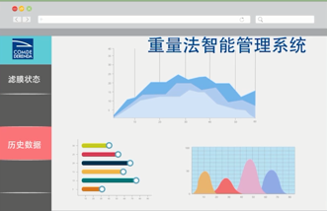
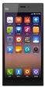
Smart phones
Cloud System
v
Burn volumes into RFID rings
Weigh
Loaded Filters
Online APM Modules
Sampling
Weigh empty filters
Weighing Unit
Cloud Server
Upload the weights of empty Filters weight
* Reset RFID Rings
* Burn the weights
of empty Filters
into RFID rings
Upload the Volumes
Cloud DB
Weighing Unit
Upload the weights of Loaded Filters
Transmit real PM2.5/PM10 concentration
Extended Interface
Concentration
Calculation
Burn loaded weights into RFID rings
Computers
Samplers
Sampler
Upload the Volumes

Samplers
The samplers are used to collect PM10, PM2.5 and PM1 particle fractions from the ambient air with a fixed air flow (1m3/h or 2.3m3/h). Here we only consider about the automatic sampling system PNT-18TDM and the system with automatic filter changer AFC-18R.
Notes: AFC-18R shall have the same data information burnt into RFID memory and uploaded to the cloud server, so it is not mentioned in the document.

PNT-18TDM
PNT-18TDM can sample totally 18 filters in one magazine and all filters can be changed automatically. To support the cloud solution, a RFID read/write device shall be installed inside to manage the RFID memory which is mounted insert of the filter cartridges. Meanwhile, PNT-18TDM also supports to upload all the data information inside of the RFID memory to the cloud server.
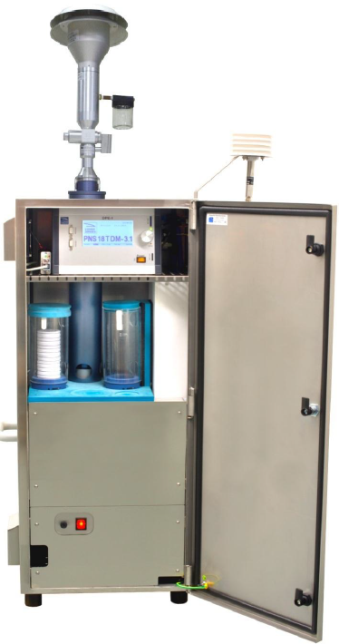
Besides the total sampling volume, the data needs to be recorded in the RFID memory and uploaded to the cloud server whenever the sampling process has been finished includes:
Stage 2: Filter Sampling
- Custom filter ID,
- Comde-Derenda Cartridge ID,
- Weight Time for empty filter,
- The 1st empty filter weight before sampling,
- The 2nd empty filter weight before sampling,
- The average empty filter weight before sampling,
- Flowrate in m3/h,
- Flowrate in Nm3/h,
- Quantity/volume in m3,
- Quantity/volume in Nm3,
- Temperature orifice,
- Ambient temperature,
- Relative humidity,
- Ambient pressure,
- Pressure filter,
- Filter temperature,
- Temperature chamber,
- Error Number.

RFID Rings
The RFID chipset which is selected to support the cloud solution is Philips Mifare 1K (s50). It contains 8kbit and 16 sectors. The main working frequency of the chipset is 13.56 MHz.
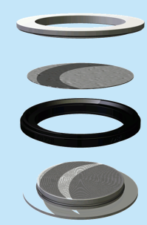
The top cover of Filter Cartridge
Sampling Filter
RFID Ring
The bottom holder of Filter Cartridge

Data Information recorded in RFID Ring
RFID Ring stores different data information for the different stages into its memory which contains 16 sectors and each of them has 512 bits (64 bytes).
Stage 1: Empty filter Weighing
The RFID memory shall be cleaned firstly and then burnt with the data containing at least:
- Custom filter ID,
- Comde-Derenda Cartridge ID,
- Weight Time for empty filter,
- The 1st empty filter weight before sampling,
- The 2nd empty filter weight before sampling,
- The average empty filter weight before sampling.
Stage 2: Filter Sampling
The RFID memory shall contain at least:
- Custom filter ID,
- Comde-Derenda Cartridge ID,
- Weight Time for empty filter,
- The 1st empty filter weight before sampling,
- The 2nd empty filter weight before sampling,
- The average empty filter weight before sampling,
- Flowrate in m3/h,
- Flowrate in Nm3/h,
- Quantity/volume in m3,
- Quantity/volume in Nm3,
- Temperature orifice,
- Ambient temperature,
- Relative humidity,
- Ambient pressure,
- Pressure filter,
- Filter temperature,
- Temperature chamber,
- Error Number.
Stage 3: Loaded Filter Weighing
The RFID memory shall contain at least:
- Custom filter ID,
- Comde-Derenda Cartridge ID,
- Weight Time for empty filter,
-The 1st empty filter weight before sampling,
- The 2nd empty filter weight before sampling,
- The average empty filter weight before sampling,
- Flowrate in m3/h,
- Flowrate in Nm3/h,
- Quantity/volume in m3,
- Quantity/volume in Nm3,
- Temperature orifice,
- Ambient temperature,
- Relative humidity,
- Ambient pressure,
- Pressure filter,
- Filter temperature,
- Temperature chamber,
- Error Number,
- Weight times for loaded filter,
- The 1st loaded filter weight after sampling,
- The 2nd loaded filter weight after sampling,
- The average loaded filter weight after sampling.

Weighing Unit
The weighing system or unit is used to weigh the empty filters before sampling and then weigh the loaded filters after sampling. The difference of the weights can be contributed to calculate the PM concentration. Comde-Derenda provides 2 kinds of weighing system to support cloud and RFID technology, including the automatic weighing system (AWS) AWS-1R and manual weighing system (MWS) MWS-1.
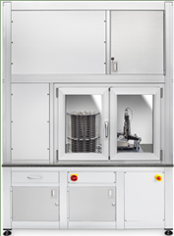
There is no difference for the data transmitted to the cloud server and recorded into RFID Ring between the AWS and MWS system. The data package shall include:
Stage 1: Empty filter Weighing
- Custom filter ID,
- Comde-Derenda Cartridge ID,
- Weight Time for empty filter,
-The 1st empty filter weight before sampling,
- The 2nd empty filter weight before sampling,
- The average empty filter weight before sampling.
Stage 3: Loaded Filter Weighing
- Custom filter ID,
- Comde-Derenda Cartridge ID,
- Weight Time for empty filter,
-The 1st empty filter weight before sampling,
- The 2nd empty filter weight before sampling,
- The average empty filter weight before sampling,
- Flowrate in m3/h,
- Flowrate in Nm3/h,
- Quantity/volume in m3,
- Quantity/volume in Nm3,
- Temperature orifice,
- Ambient temperature,
- Relative humidity,
- Ambient pressure,
- Pressure filter,
- Filter temperature,
- Temperature chamber,
- Error Number,
- Weight times for loaded filter,
- The 1st loaded filter weight after sampling,
- The 2nd loaded filter weight after sampling,
- The average loaded filter weight after sampling.

The Cloud Server
The Cloud Server which plays as the key handler in Comde-Derenda cloud architecture is mainly responsible to:
- Receive and check the data flow uploaded from the end units including the samplers, online APM module, the weighing system and some other extended interface devices.
- The cloud database management
- Calculate and record the PM concentration by analyzing the received data from the end units
- Provide the friendly UI to support the historic data inquiry, data editing and the remote control from all kinds of user devices including the smart phones (IOS and Android) and PCs

The Cloud Database
The Cloud database stores all the data needed to support Comde-Derenda cloud technology solution. Disaster Recovery strategy shall be considered to guarantee the safety of the key data. Load balance strategy shall be considered to guarantee the access bandwidth for the customers.
Notes: we shall think about the database structure to support about 1000 end units alive simultaneously.

Online APM modules
APM-2 or APM-6 can monitor the air pollution including PM2.5 and PM10 dynamically and send the real data to the cloud sever periodically.
Notes: APM-2 is the same as APM-6 from out looking. APM-6 not only integrates all the functionalities from APM-2, but also involves an additional gas module to monitor the gas concentrations of SO2, CO, O3 and NO
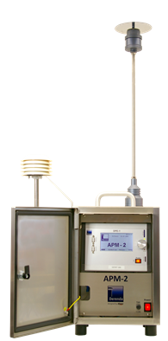

APM-2
The data sent to the cloud server for APM-2 includes:
- Date
- Time
- Type
- Device D/N
- Flush
- PM2.5
- PM10
- Motor speed
- Photometer Temperature
- Air Pressure
- Outdoor Temperature
- Rel. Humidity
- Event

APM-6
The data sent to the cloud server for APM-6 includes:
- Date
- Time
- Type
- Device D/N
- Flush
- PM2.5
- PM10
- Motor speed
- Photometer Temperature
- Air Pressure
- Outdoor Temperature
- Rel. Humidity
- Event
- NO
- CO
- SO2
- O3

Mobile UAP
The cloud solution also includes the mobile apps that can help the customers or administers to:
- Inquire the sampling and weighing information of the filter offline via scanning the RIFD ring
- Calculate the PM concentration by using the information burnt in the RIFD ring
- Inquire the filter information online via inputting the customer filter ID number

PC UAP
The cloud solution includes the browser-based application that can retrieve the data from cloud database and help the customers or administers to:
- Inquire the sampling and weighing information of the filter online via accessing to the cloud database through cloud server
- Edit the sampling or weighing data under the configurable privilege
- Remote control for the devices including samplers, weighing units, APM modules and other extended units which are alive
- An Online chart or diagram is provided as the summary report generated based on the historic data

The extended interface
The extended interface is used for the growth usage to support the devices that are not currently listed in the sections above.

DnD Engineering Process
End
New Product
New Feature
Performance Improvement
Customer
Mkt / Sales
Engineering
Stage 0: Design
Create DnDS
DnDS Review
Mkt
RnD
Customer
Mkt
RnD
Decision Point ?
Management
Customer

To Stage 1:
Implementation
Output:
DnDS Rev 1.0

Input:
DnDS Rev 1.0
RnD Engineering
3rd Part Developers
Output:
DnDS Rev 2.0
DnIS Rev 1.0
V&V Report v1.0
User Manual v1.0
Dry Run Prototype
Stage 1: Implementation
MD
FW
HW
SW
System Integrated
Verification Validation
Prototype
Readiness
Prototype Delivery for customer Review
Decision Point ?
End
To Stage 2:
Final Delivery
Management
Customer

Stage 2: Final
Delivery
Input:
DnDS Rev 2.0
DnIS Rev 1.0
V&V Report v1.0
User Manual v1.0
Prototype
Prototype
Production
Requirements
Certification
Development
Frozen
DP ?
Engineering
Marketing
Management
Customer

Output:
DnDS Rev 3.0
DnIS Rev 2.0
V&V Report v2.0
USR Manual v2.0
Final Delivery
PRD Manual
Final
Delivery
Closure

Specialty Engineering Services

Reliability/Maintainability/Availability Engineering

Human Factors Engineering

Environmental & Electromagnetic Engineering (EEE)

Appendix

